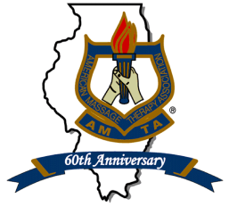AMTA-IL BOARD OF DIRECTORS CANDIDATE APPLICATION
P. O. Box 55 * O’Fallon, IL 62269
Email TO THE CHAPTER OFFICE BY Tuesday February 14, 2017
illinois@amtamassage.org

Name_________________________________________________________________________
Address_______________________________________________________________________
City_______________________________ State___IL_____________ Zip_________________
Tel________________________________ Best time to contact you_______________________
Email_________________________________________________________________________

I am interested in candidacy for the following position (please check one):

- Board Member (2 year term) 2017-2019
- Financial Administrator (2 year term) 2017-2019

Are you a Professional Member, in good standing, of AMTA? 􀂈 Yes 􀂈 No
AMTA membership #: ___________________Year you joined AMTA:___________________
IL License #: _______________________Number of Years in massage:___________________
Massage Training (school or other):________________________________________________
1.List AMTA Chapter and National offices held (including dates), committee work, other community or professional experience:
____________________________________________________________________________________________________________________________________________________________
2. Attach a 200 word statement about yourself and your reasons and objectives for seeking this office. This statement will be sent to members along with election materials.
3. Please also attach a current resume, or summary of your education and work experience in massage therapy and other occupations.

Your signature below indicates your commitment to devote the appropriate amount of time for the performance of duties and attendance at the monthly Chapter Board meetings, Chapter Officer Training, Chapter Annual Meeting and AMTA National Conventions. Time commitment: approximately 6-8 hours per week for officers.

Signature__________________________________________ Date________________________

Candidates will be introduced at the Annual Meeting in Oak Brook, IL on Saturday, March 25, 2017. Candidates are not required to be present, but it is highly recommended that they attend.

